MTCT Web3 SSI System Technical Specification

**Overview**

This document provides a detailed technical specification for the implementation of the MTCT Web3 SSI system. The system focuses on Web3 SSI-based customer onboarding, utilising verifiable credentials for asset management, and is designed for both on-premise and cloud-native deployment.

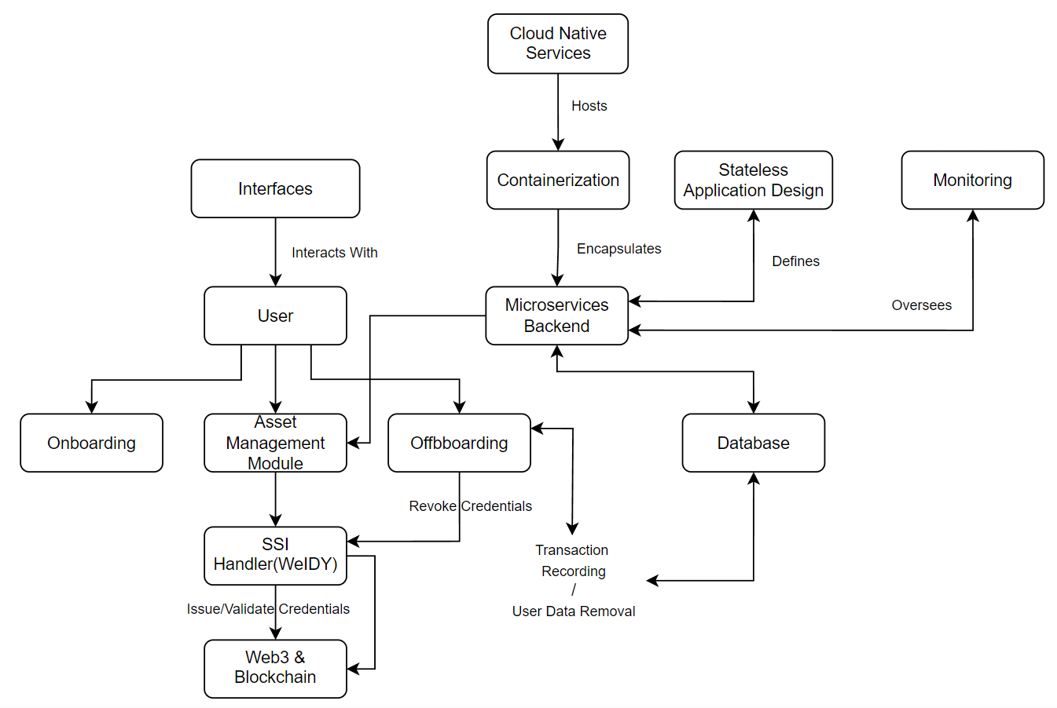

**Components and Services**

Web Browser: The primary interface for users to access the MTCT platform.

Load Balancer: Distributes incoming traffic across multiple instances to ensure optimal resource utilization.

Express Server: Serves APIs and acts as the middleman between the frontend and backend.

SSI Handler (WeIDY):

Onboards users via verifiable credentials.

Integrates with Aries, Indy, etc.

Validates & issues verifiable credentials.

Provides the capability to prove, revoke, and verify credentials.

Web3 & Blockchain: Connects with Ethereum blockchain or other supported blockchain networks for smart contract deployments and interactions.

Asset Management Module: Handles CRUD operations for products, transaction recording, product ownership, and transfer.

Database: A hybrid architecture with both on-premise and cloud DBs. Ensures regular sync or real-time data replication between databases and sharding for scalability.

Micro-services Backend: Supports the asset management module and other functionalities.

Interfaces: Various user interfaces to interact with the system.

Containerization: Encapsulates the micro-services backend for isolated deployments and scaling.

Cloud-native Services: Hosts the containerized applications on platforms like AWS, Azure, or GCP.

Stateless Application Design: Ensures easy scalability of the system.

Centralized Logging: Tools like ELK Stack for monitoring and logging system activities.

Monitoring: Tools like Prometheus and Grafana for system health checks and alerts.

**Rationale**

Web3 Integration: Provides a decentralized approach to identity management, ensuring security and privacy.

SSI Handler (WeIDY): Enables a trustable and secure transactional environment using verifiable credentials.

Asset Management Module: Ensures seamless management of assets with the added security of verifiable credentials.

Database Design: The hybrid architecture ensures data availability, redundancy, and scalability.

Micro-services Architecture: Provides flexibility, scalability, and ease of maintenance.

Containerization & Cloud-native Services: Ensures efficient resource utilization, scalability, and high availability.

Stateless Design: Enhances the system's scalability by ensuring that each request from a client to a server is treated as a new request.

Centralized Logging & Monitoring: Provides insights into system performance, potential issues, and ensures system health.

**Implementation Flow**

A user accesses the MTCT platform for onboarding.

They are directed to WeIDY for SSI credential creation/submission.

WeIDY interacts with Web3 for credential validation and storage on the blockchain.

Post-validation, the user gains access to the MTCT platform for asset management.

Verifiable credentials ensure a trustable environment for transactions.

On offboarding, user credentials can be revoked or retained for future interactions.